RAID
RAID, or “Redundant Arrays of Independent Disks” is a technique which makes use of a combination of multiple disks instead of using a single disk for increased performance, data redundancy or both. The term was coined by David Patterson, Garth A. Gibson, and Randy Katz at the University of California, Berkeley in 1987.
Why data redundancy?
Data redundancy, although taking up extra space, adds to disk reliability. This means, in case of disk failure, if the same data is also backed up onto another disk, we can retrieve the data and go on with the operation. On the other hand, if the data is spread across just multiple disks without the RAID technique, the loss of a single disk can affect the entire data.
What is the problem with single disk storage?
- No backup Disk: If a single disk failure occurs, the whole system fails to perform. Due to data Redundancy if copy of data is stored in multiple disks then even if one disk failure occurs the system can still fetch data from the other redundant disk.
- Performance: If large amount of data is stored in a single disk it can degrade the performance and effectiveness of the system. This can be solved by using multiple disks with Redundant data.
Key evaluation points for a RAID System
- Reliability: How many disk faults can the system tolerate?
- Availability: What fraction of the total session time is a system in uptime mode, i.e. how available is the system for actual use?
- Performance: How good is the response time? How high is the throughput (rate of processing work)? Note that performance contains a lot of parameters and not just the two.
- Capacity: Given a set of N disks each with B blocks, how much useful capacity is available to the user?

RAID is very transparent to the underlying system. This means, to the host system, it appears as a single big disk presenting itself as a linear array of blocks. This allows older technologies to be replaced by RAID without making too many changes in the existing code.

RAID technology
There are 7 levels of RAID schemes. These schemas are as RAID 0, RAID 1, , RAID 2, , RAID 3, , RAID 4, , RAID 5, RAID 6.
These levels contain the following characteristics:
- It contains a set of physical disk drives.
- In this technology, the operating system views these separate disks as a single logical disk.
- In this technology, data is distributed across the physical drives of the array.
- Redundancy disk capacity is used to store parity information.
- In case of disk failure, the parity information can be helped to recover the data.

RAID 0
- RAID level 0 provides data stripping, i.e., a data can place across multiple disks. It is based on stripping that means if one disk fails then all data in the array is lost.
- This level doesn't provide fault tolerance but increases the system performance.

Example:
Disk 0 | Disk 1 | Disk 2 | Disk 3
20 | 21 | 22 | 23
24 | 25 | 26 | 27
28 | 29 | 30 | 31
32 | 33 | 34 | 35
In this figure, block 0, 1, 2, 3 form a stripe.
In this level, instead of placing just one block into a disk at a time, we can work with two or more blocks placed it into a disk before moving on to the next one.
Disk 0 | Disk 1 | Disk 2 | Disk 3
20 | 22 | 24 | 26
21 | 23 | 25 | 27
28 | 30 | 32 | 34
29 | 31 | 33 | 35
In this above figure, there is no duplication of data. Hence, a block once lost cannot be recovered.

Pros of RAID 0:
- In this level, throughput is increased because multiple data requests probably not on the same disk.
- This level full utilizes the disk space and provides high performance.
- It requires minimum 2 drives.

Cons of RAID 0:
- It doesn't contain any error detection mechanism.
- The RAID 0 is not a true RAID because it is not fault-tolerance.
- In this level, failure of either disk results in complete data loss in respective array.

RAID 1
This level is called mirroring of data as it copies the data from drive 1 to drive 2. It provides 100% redundancy in case of a failure.

Example:
Disk 0 | Disk 1 | Disk 2 | Disk 3
A | A | B | B
C | C | D | D
E | E | F | F
G | G | H | H
Only half space of the drive is used to store the data. The other half of drive is just a mirror to the already stored data.

Pros of RAID 1:
- The main advantage of RAID 1 is fault tolerance. In this level, if one disk fails, then the other automatically takes over.
- In this level, the array will function even if any one of the drives fails.

Cons of RAID 1:
- In this level, one extra drive is required per drive for mirroring, so the expense is higher.

RAID 2
- RAID 2 uses bit level striping. i.e Instead of striping the blocks across the disks, it stripes the bits across the disks.
- In the above diagram b1, b2, b3 are bits. E1, E2, E3 are error correction codes.
- You need two groups of disks. One group of disks are used to write the data, another group is used to write the error correction codes.
- This uses Hamming error correction code (ECC), and stores this information in the redundancy disks.
- When data is written to the disks, it calculates the ECC code for the data on the fly, and stripes the data bits to the data-disks, and writes the ECC code to the redundancy disks.
- When data is read from the disks, it also reads the corresponding ECC code from the redundancy disks, and checks whether the data is consistent. If required, it makes appropriate corrections on the fly.
- This uses lot of disks and can be configured in different disk configuration. Some valid configurations are 1) 10 disks for data and 4 disks for ECC 2) 4 disks for data and 3 disks for ECC
- This is not used anymore. This is expensive and implementing it in a RAID controller is complex, and ECC is redundant now-a-days, as the hard disk themselves can do this.
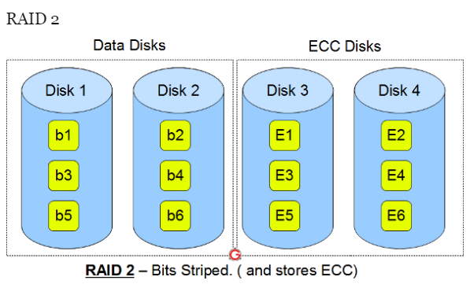
Pros of RAID 2:
- This level uses one designated drive to store parity.
- It uses the hamming code for error detection.

Cons of RAID 2:
- It requires an additional drive for error detection.

RAID 3
- RAID 3 uses byte level striping. i.e Instead of striping the blocks across the disks, it stripes the bytes across the disks.
- In the above diagram B1, B2, B3 are bytes. p1, p2, p3 are parities.
- Uses multiple data disks, and a dedicated disk to store parity.
- The disks have to spin in sync to get to the data.
- Sequential read and write will have good performance.
- Random read and write will have worst performance.
- This is not commonly used.
- In case of drive failure, the parity drive is accessed, and data is reconstructed from the remaining devices. Once the failed drive is replaced, the missing data can be restored on the new drive.
- In this level, data can be transferred in bulk. Thus high-speed data transmission is possible.

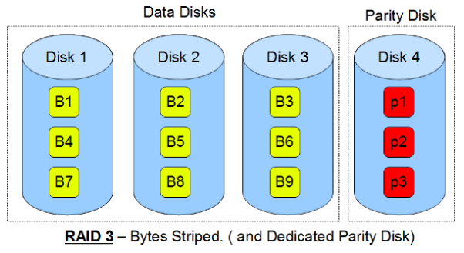

Pros of RAID 3:
- In this level, data is regenerated using parity drive.
- It contains high data transfer rates.
- In this level, data is accessed in parallel.

Cons of RAID 3:
- It required an additional drive for parity.
- It gives a slow performance for operating on small sized files.

RAID 4
- RAID 4 uses block level striping.
- In the above diagram B1, B2, B3 are blocks. p1, p2, p3 are parities.
- Uses multiple data disks, and a dedicated disk to store parity.
- Minimum of 3 disks (2 disks for data and 1 for parity)
- Good random reads, as the data blocks are striped.
- Bad random writes, as for every write, it has to write to the single parity disk.
- It is somewhat similar to RAID 3 and 5, but a little different.
- This is just like RAID 3 in having the dedicated parity disk, but this stripes blocks.
- This is just like RAID 5 in striping the blocks across the data disks, but this has only one parity disk.
- This is not commonly used.

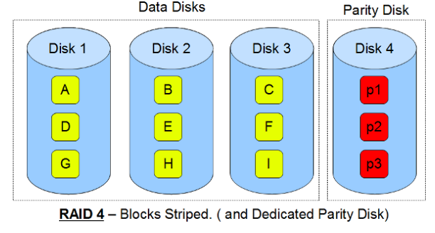

RAID 5
- RAID 5 is a slight modification of the RAID 4 system. The only difference is that in RAID 5, the parity rotates among the drives.
- It consists of block-level striping with DISTRIBUTED parity.
- Same as RAID 4, this level allows recovery of at most 1 disk failure. If more than one disk fails, then there is no way for data recovery.
Disk 0 | Disk 1 | Disk 2 | Disk 3 | Disk 4
0 | 1 | 2 | 3 | P0
5 | 6 | 7 | P1 | 4
10 | 11 | P2 | 8 | 9
15 | P3 | 12 | 13 | 14
P4 | 16 | 17 | 18 | 19
This figure shows that how parity bit rotates.
This level was introduced to make the random write performance better.

Pros of RAID 5:
- This level is cost effective and provides high performance.
- In this level, parity is distributed across the disks in an array.
- It is used to make the random write performance better.

Cons of RAID 5:
- In this level, disk failure recovery takes longer time as parity has to be calculated from all available drives.
- This level cannot survive in concurrent drive failure.

RAID 6
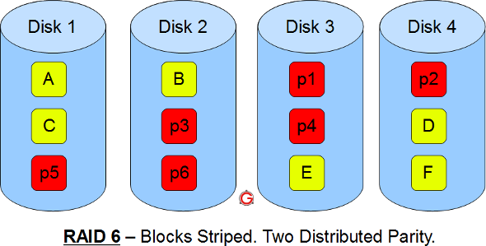
- Just like RAID 5, this does block level striping. However, it uses dual parity.
- In the above diagram A, B, C are blocks. p1, p2, p3 are parities.
- This creates two parity blocks for each data block.
- Can handle two disk failure
- This RAID configuration is complex to implement in a RAID controller, as it has to calculate two parity data for each data block.

Pros of RAID 6:
- This level performs RAID 0 to strip data and RAID 1 to mirror. In this level, stripping is performed before mirroring.
- In this level, drives required should be multiple of 2.

Cons of RAID 6:
- It is not utilized 100% disk capability as half is used for mirroring.
- It contains very limited scalability.

File Organization
A database consist of a huge amount of data. The data is grouped within a table in RDBMS, and each table have related records. A user can see that the data is stored in form of tables, but in actual this huge amount of data is stored in physical memory in form of files.
File – A file is named collection of related information that is recorded on secondary storage such as magnetic disks, magnetic tables and optical disks.

What is File Organization?

File Organization refers to the logical relationships among various records that constitute the file, particularly with respect to the means of identification and access to any specific record. In simple terms, Storing the files in certain order is called file Organization. File Structure refers to the format of the label and data blocks and of any logical control record.

Objective of file organization:
1) Optimal Selection Of Records: This refers that record should be accessed as fast as possible.
2) Easy Transaction: Any insert, update or Delete transaction i.e operations on record should be easy. It should be quick and easy and should not harm other records.
3) No Duplicate Record: There No duplicate record should be induced as a result of Insert, Update or Delete.
4) Efficient Storing: Records should be stored efficiently so that cost of storage is minimal: Empty blocks of file / between the records should be utilized.

Types of files:

1.Physical file:
- Physical file concern with actual data that is stored.
- It stores description about how the data is to be represented.

2. Logical File
- Logical file: do not contain data.
- They contain a description of records that are found in one or more physical files.
- A logical file is a view or representation of one or more physical files.

3.Special character file:
- At the time of file creation we insert some special characters in file.
- For eg: Control + z for end of a file which having ASCII value 26

According to records types of files:
1. Fixed length record file
2. Variable length record file

1. Fixed length record file:
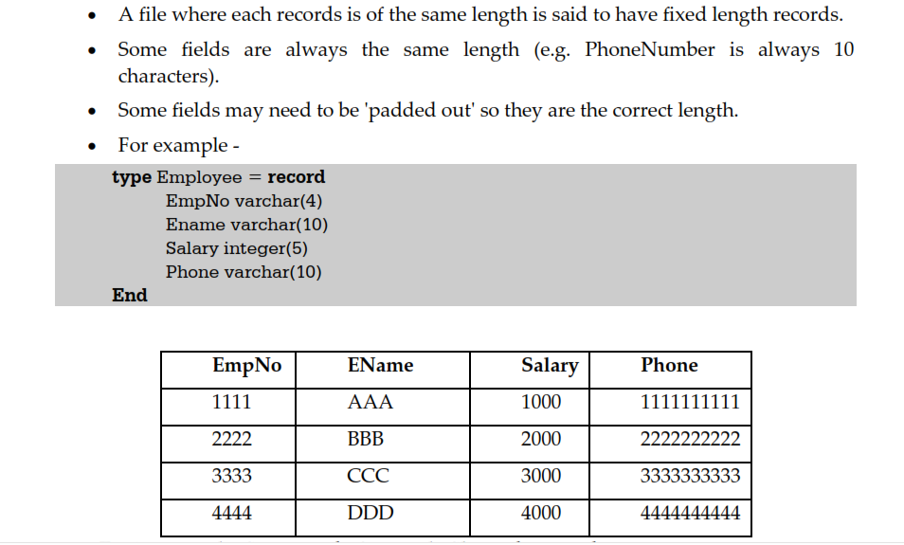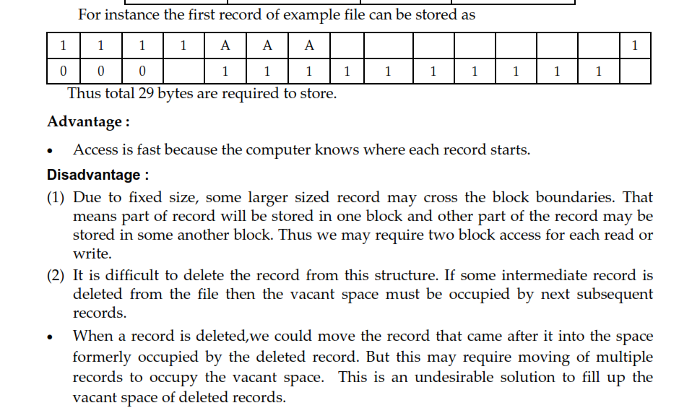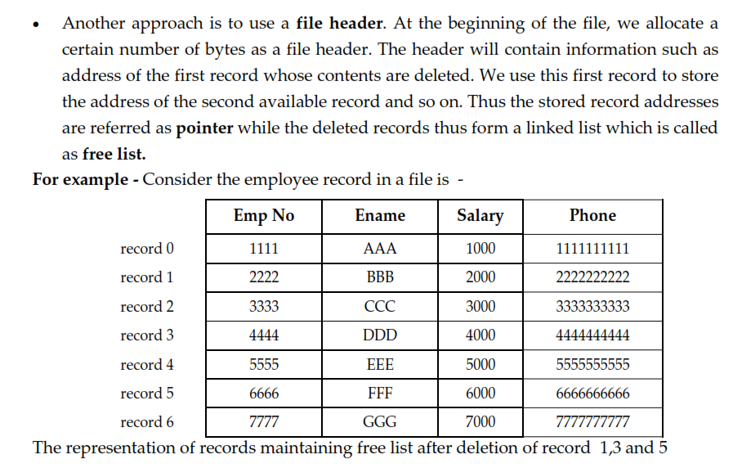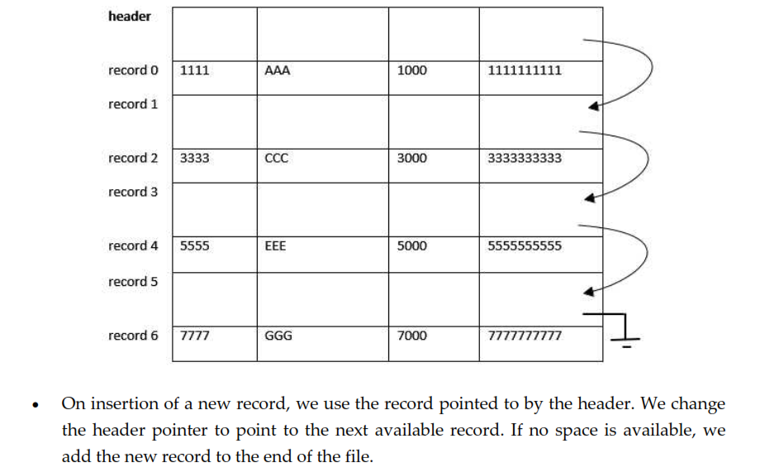

2. Variable length record file:
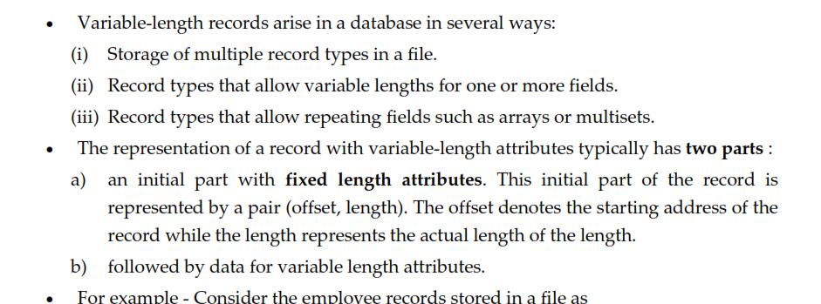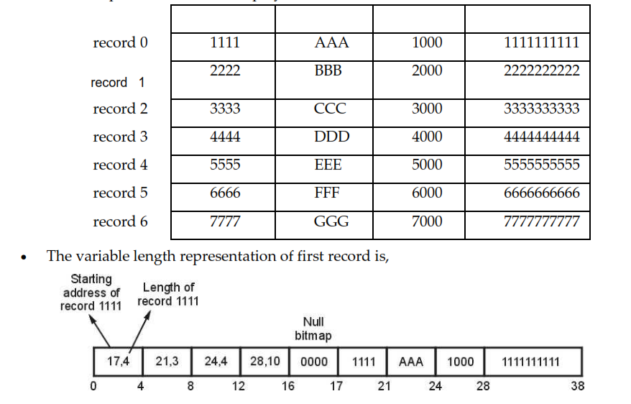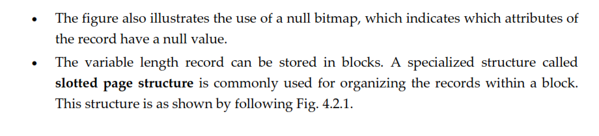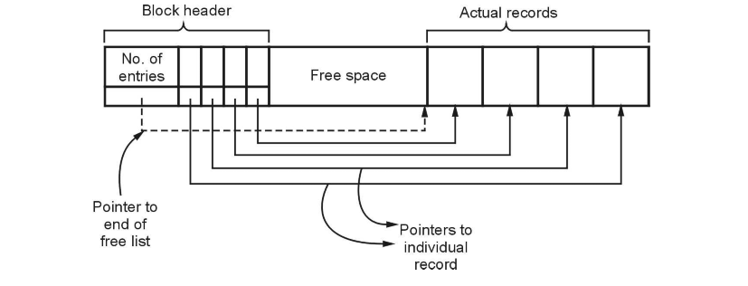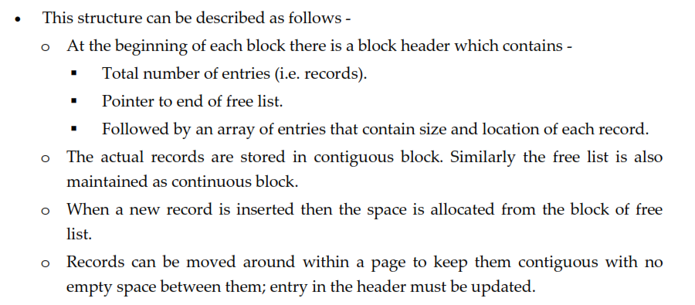

Organization of Records in Files
File organization contains various methods. These particular methods have pros and cons on the basis of access or selection. In the file organization, the programmer decides the best-suited file organization method according to his requirement.
Types of file organization are as follows:
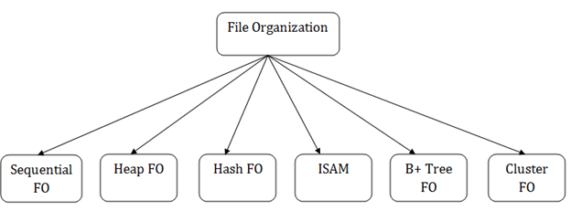
- Sequential file organization
- Heap file organization
- Hash file organization
- B+ file organization
- Indexed sequential access method (ISAM)
- Cluster file organization

1. Sequential File Organization
This method is the easiest method for file organization. In this method, files are stored sequentially. This method can be implemented in two ways:

1. Pile File Method:
- It is a quite simple method. In this method, we store the record in a sequence, i.e., one after another. Here, the record will be inserted in the order in which they are inserted into tables.
- In case of updating or deleting of any record, the record will be searched in the memory blocks. When it is found, then it will be marked for deleting, and the new record is inserted.
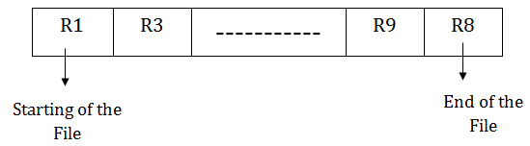

Insertion of the new record:
Suppose we have four records R1, R3 and so on upto R9 and R8 in a sequence. Hence, records are nothing but a row in the table. Suppose we want to insert a new record R2 in the sequence, then it will be placed at the end of the file. Here, records are nothing but a row in any table.
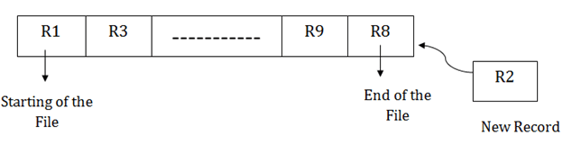

2. Sorted File Method:
- In this method, the new record is always inserted at the file's end, and then it will sort the sequence in ascending or descending order. Sorting of records is based on any primary key or any other key.
- In the case of modification of any record, it will update the record and then sort the file, and lastly, the updated record is placed in the right place.

Insertion of the new record:
Suppose there is a preexisting sorted sequence of four records R1, R3 and so on upto R6 and R7. Suppose a new record R2 has to be inserted in the sequence, then it will be inserted at the end of the file, and then it will sort the sequence.
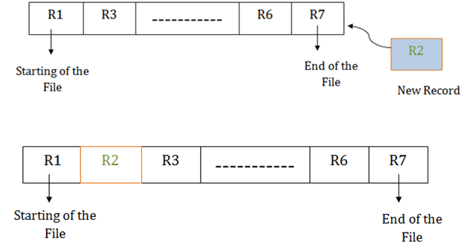

Pros of sequential file organization
- It contains a fast and efficient method for the huge amount of data.
- In this method, files can be easily stored in cheaper storage mechanism like magnetic tapes.
- It is simple in design. It requires no much effort to store the data.
- This method is used when most of the records have to be accessed like grade calculation of a student, generating the salary slip, etc.
- This method is used for report generation or statistical calculations.

Cons of sequential file organization
- It will waste time as we cannot jump on a particular record that is required but we have to move sequentially which takes our time.
- Sorted file method takes more time and space for sorting the records.

2. Heap file organization
- It is the simplest and most basic type of organization. It works with data blocks. In heap file organization, the records are inserted at the file's end. When the records are inserted, it doesn't require the sorting and ordering of records.
- When the data block is full, the new record is stored in some other block. This new data block need not to be the very next data block, but it can select any data block in the memory to store new records. The heap file is also known as an unordered file.
- In the file, every record has a unique id, and every page in a file is of the same size. It is the DBMS responsibility to store and manage the new records.
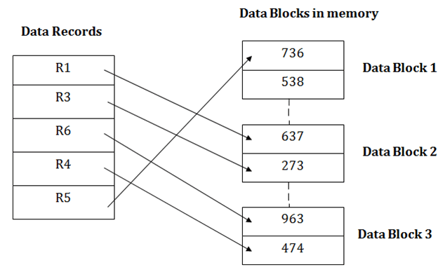

Insertion of a new record
Suppose we have five records R1, R3, R6, R4 and R5 in a heap and suppose we want to insert a new record R2 in a heap. If the data block 3 is full then it will be inserted in any of the database selected by the DBMS, let's say data block 1.
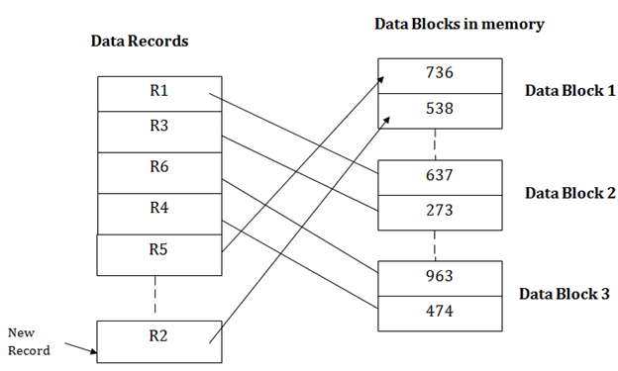
If we want to search, update or delete the data in heap file organization, then we need to traverse the data from staring of the file till we get the requested record.
If the database is very large then searching, updating or deleting of record will be time-consuming because there is no sorting or ordering of records. In the heap file organization, we need to check all the data until we get the requested record.

Pros of Heap file organization
- It is a very good method of file organization for bulk insertion. If there is a large number of data which needs to load into the database at a time, then this method is best suited.
- In case of a small database, fetching and retrieving of records is faster than the sequential record.

Cons of Heap file organization
- This method is inefficient for the large database because it takes time to search or modify the record.
- This method is inefficient for large databases.

3.Hash File Organization
Hash File Organization uses the computation of hash function on some fields of the records. The hash function's output determines the location of disk block where the records are to be placed.
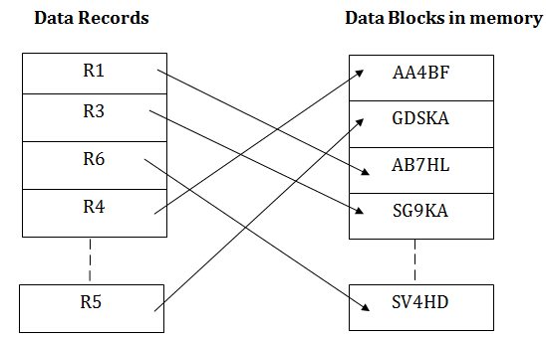
When a record has to be received using the hash key columns, then the address is generated, and the whole record is retrieved using that address. In the same way, when a new record has to be inserted, then the address is generated using the hash key and record is directly inserted. The same process is applied in the case of delete and update.
In this method, there is no effort for searching and sorting the entire file. In this method, each record will be stored randomly in the memory.
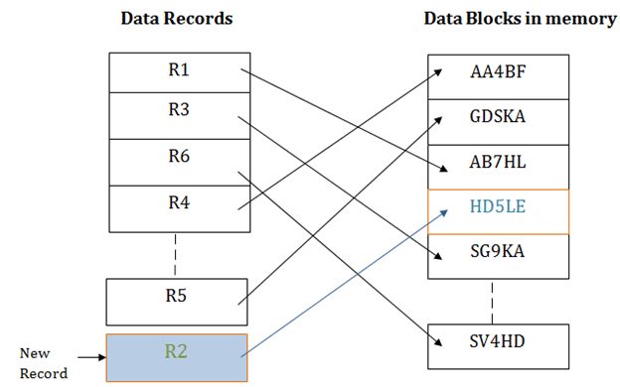

4.B+ File Organization
- B+ tree file organization is the advanced method of an indexed sequential access method. It uses a tree-like structure to store records in File.
- It uses the same concept of key-index where the primary key is used to sort the records. For each primary key, the value of the index is generated and mapped with the record.
- The B+ tree is similar to a binary search tree (BST), but it can have more than two children. In this method, all the records are stored only at the leaf node. Intermediate nodes act as a pointer to the leaf nodes. They do not contain any records.
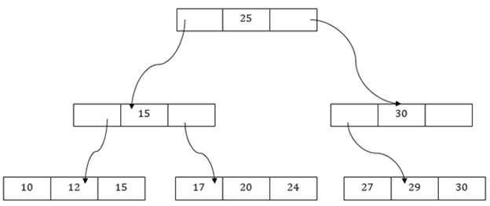

The above B+ tree shows that:
- There is one root node of the tree, i.e., 25.
- There is an intermediary layer with nodes. They do not store the actual record. They have only pointers to the leaf node.
- The nodes to the left of the root node contain the prior value of the root and nodes to the right contain next value of the root, i.e., 15 and 30 respectively.
- There is only one leaf node which has only values, i.e., 10, 12, 17, 20, 24, 27 and 29.
- Searching for any record is easier as all the leaf nodes are balanced.
- In this method, searching any record can be traversed through the single path and accessed easily.

Pros of B+ tree file organization
- In this method, searching becomes very easy as all the records are stored only in the leaf nodes and sorted the sequential linked list.
- Traversing through the tree structure is easier and faster.
- The size of the B+ tree has no restrictions, so the number of records can increase or decrease and the B+ tree structure can also grow or shrink.
- It is a balanced tree structure, and any insert/update/delete does not affect the performance of tree.

Cons of B+ tree file organization
- This method is inefficient for the static method.

5.Indexed sequential access method (ISAM)
ISAM method is an advanced sequential file organization. In this method, records are stored in the file using the primary key. An index value is generated for each primary key and mapped with the record. This index contains the address of the record in the file.
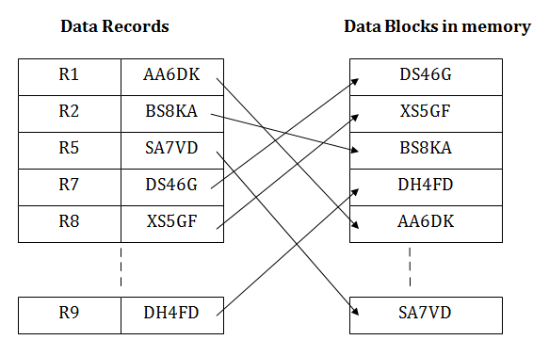
If any record has to be retrieved based on its index value, then the address of the data block is fetched and the record is retrieved from the memory.

Pros of ISAM:
- In this method, each record has the address of its data block, searching a record in a huge database is quick and easy.
- This method supports range retrieval and partial retrieval of records. Since the index is based on the primary key values, we can retrieve the data for the given range of value. In the same way, the partial value can also be easily searched, i.e., the student name starting with 'JA' can be easily searched.

Cons of ISAM
- This method requires extra space in the disk to store the index value.
- When the new records are inserted, then these files have to be reconstructed to maintain the sequence.
- When the record is deleted, then the space used by it needs to be released. Otherwise, the performance of the database will slow down.

6.Cluster file organization
- When the two or more records are stored in the same file, it is known as clusters. These files will have two or more tables in the same data block, and key attributes which are used to map these tables together are stored only once.
- This method reduces the cost of searching for various records in different files.
- The cluster file organization is used when there is a frequent need for joining the tables with the same condition. These joins will give only a few records from both tables. In the given example, we are retrieving the record for only particular departments. This method can't be used to retrieve the record for the entire department.
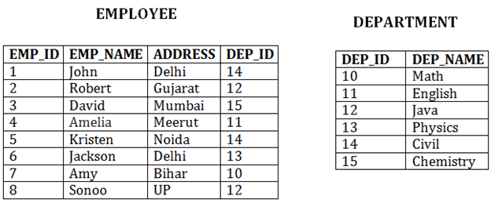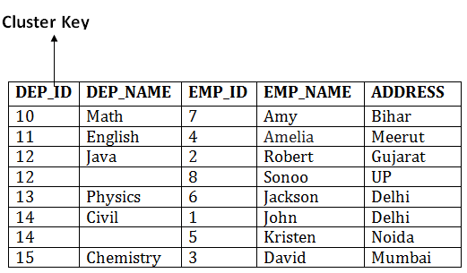
In this method, we can directly insert, update or delete any record. Data is sorted based on the key with which searching is done. Cluster key is a type of key with which joining of the table is performed.

Types of Cluster file organization:
Cluster file organization is of two types:

1. Indexed Clusters:
In indexed cluster, records are grouped based on the cluster key and stored together. The above EMPLOYEE and DEPARTMENT relationship is an example of an indexed cluster. Here, all the records are grouped based on the cluster key- DEP_ID and all the records are grouped.

2. Hash Clusters:
It is similar to the indexed cluster. In hash cluster, instead of storing the records based on the cluster key, we generate the value of the hash key for the cluster key and store the records with the same hash key value.

Pros of Cluster file organization
- The cluster file organization is used when there is a frequent request for joining the tables with same joining condition.
- It provides the efficient result when there is a 1:M mapping between the tables.

Cons of Cluster file organization
- This method has the low performance for the very large database.
- If there is any change in joining condition, then this method cannot use. If we change the condition of joining then traversing the file takes a lot of time.
- This method is not suitable for a table with a 1:1 condition.

Indexing and Hashing

Indexing:
- Indexing is used to optimize the performance of a database by minimizing the number of disk accesses required when a query is processed.
- The index is a type of data structure. It is used to locate and access the data in a database table quickly.

Index structure:
Indexes can be created using some database columns.
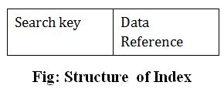
- The first column of the database is the search key that contains a copy of the primary key or candidate key of the table. The values of the primary key are stored in sorted order so that the corresponding data can be accessed easily.
- The second column of the database is the data reference. It contains a set of pointers holding the address of the disk block where the value of the particular key can be found.

Hashing

In a huge database structure, it is very inefficient to search all the index values and reach the desired data. Hashing technique is used to calculate the direct location of a data record on the disk without using index structure.
In this technique, data is stored at the data blocks whose address is generated by using the hashing function. The memory location where these records are stored is known as data bucket or data blocks.
In this, a hash function can choose any of the column value to generate the address. Most of the time, the hash function uses the primary key to generate the address of the data block. A hash function is a simple mathematical function to any complex mathematical function. We can even consider the primary key itself as the address of the data block. That means each row whose address will be the same as a primary key stored in the data block.
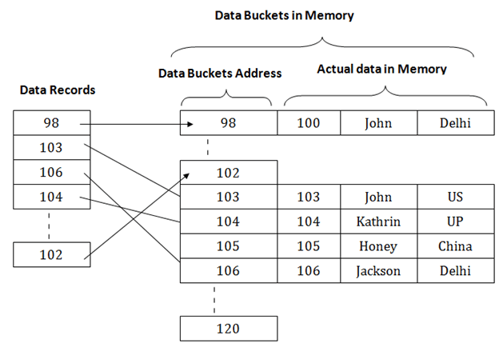
The above diagram shows data block addresses same as primary key value. This hash function can also be a simple mathematical function like exponential, mod, cos, sin, etc. Suppose we have mod (5) hash function to determine the address of the data block. In this case, it applies mod (5) hash function on the primary keys and generates 3, 3, 1, 4 and 2 respectively, and records are stored in those data block addresses.2.8MUbuntu 20.04 Desktop Tour: Check Out New Features
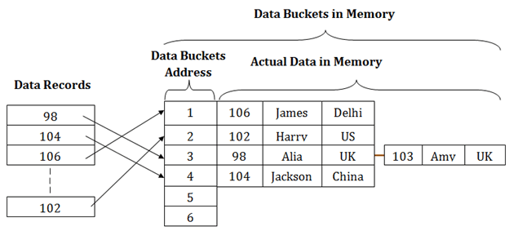

Hashing is an efficient technique to directly search the location of desired data on the disk without using index structure. Data is stored at the data blocks whose address is generated by using hash function. The memory location where these records are stored is called as data block or data bucket.

Hash File Organization :
- Data bucket – Data buckets are the memory locations where the records are stored. These buckets are also considered as Unit Of Storage.
- Hash Function – Hash function is a mapping function that maps all the set of search keys to actual record address. Generally, hash function uses primary key to generate the hash index – address of the data block. Hash function can be simple mathematical function to any complex mathematical function.
- Hash Index-The prefix of an entire hash value is taken as a hash index. Every hash index has a depth value to signify how many bits are used for computing a hash function. These bits can address 2n buckets. When all these bits are consumed ? then the depth value is increased linearly and twice the buckets are allocated.
Below given diagram clearly depicts how hash function work:
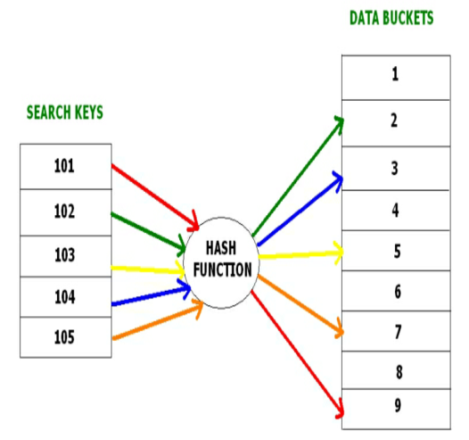
Hashing is further divided into two sub categories :
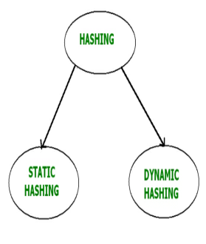

Ordered Indices
Imagine we have a student table with thousands of records, each of which is 10 bytes long. Imagine their IDs start from 1 2, 3… and goes on. And we have to search student with ID 678. In a normal database with no index, it searches the disk block from the beginning till it reaches 678. So the DBMS will reach this record after reading 677*10 = 6770 bytes. But if we have index on ID column, then the address of the location will be stored as each record as (1,200), (2, 201)… (678, 879) and so on. One can imagine it as a smaller table with index column and address column. Now if we want to search record with ID 678, then it will search using indexes. i.e.; here it will traverse only 677*2 = 1354 bytes which very less compared to earlier one. Hence retrieving the record from the disk becomes faster. Most of the cases these indexes are sorted and kept to make searching faster. If the indexes are sorted, then it is called as ordered indices.

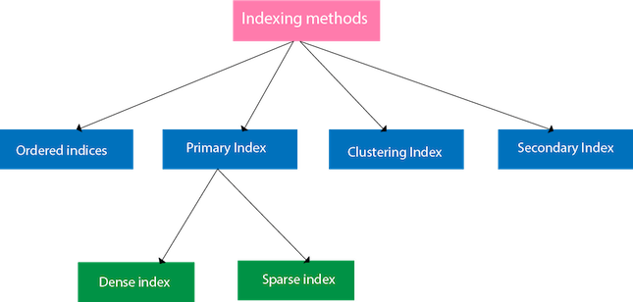

Ordered indices
The indices are usually sorted to make searching faster. The indices which are sorted are known as ordered indices.
Example: Suppose we have an employee table with thousands of record and each of which is 10 bytes long. If their IDs start with 1, 2, 3....and so on and we have to search student with ID-543.
- In the case of a database with no index, we have to search the disk block from starting till it reaches 543. The DBMS will read the record after reading 543*10=5430 bytes.
- In the case of an index, we will search using indexes and the DBMS will read the record after reading 542*2= 1084 bytes which are very less compared to the previous case.

Primary Index
- If the index is created on the basis of the primary key of the table, then it is known as primary indexing. These primary keys are unique to each record and contain 1:1 relation between the records.
- As primary keys are stored in sorted order, the performance of the searching operation is quite efficient.
- The primary index can be classified into two types: Dense index and Sparse index.

Dense index
- The dense index contains an index record for every search key value in the data file. It makes searching faster.
- In this, the number of records in the index table is same as the number of records in the main table.
- It needs more space to store index record itself. The index records have the search key and a pointer to the actual record on the disk.
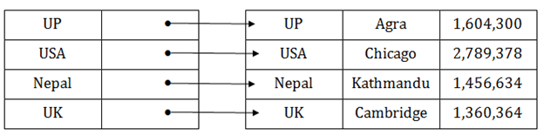

Sparse index
- In the data file, index record appears only for a few items. Each item points to a block.
- In this, instead of pointing to each record in the main table, the index points to the records in the main table in a gap.
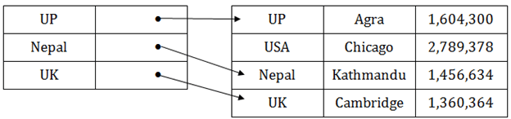

Clustering Index
- A clustered index can be defined as an ordered data file. Sometimes the index is created on non-primary key columns which may not be unique for each record.
- In this case, to identify the record faster, we will group two or more columns to get the unique value and create index out of them. This method is called a clustering index.
- The records which have similar characteristics are grouped, and indexes are created for these group.
Example: suppose a company contains several employees in each department. Suppose we use a clustering index, where all employees which belong to the same Dept_ID are considered within a single cluster, and index pointers point to the cluster as a whole. Here Dept_Id is a non-unique key.3.3M
72
Twitter Rolls Out New Feature That Lets You ‘Unmention’ Yourself From a Tweet
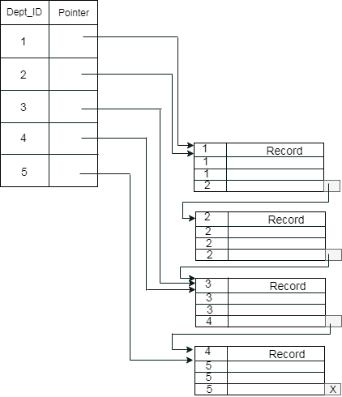
The previous schema is little confusing because one disk block is shared by records which belong to the different cluster. If we use separate disk block for separate clusters, then it is called better technique.
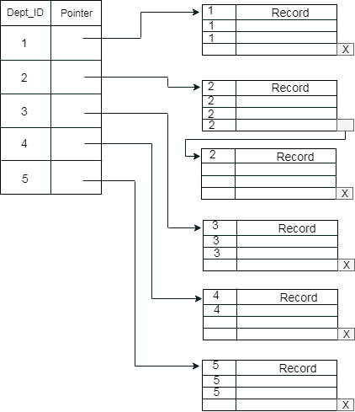

Secondary Index
In the sparse indexing, as the size of the table grows, the size of mapping also grows. These mappings are usually kept in the primary memory so that address fetch should be faster. Then the secondary memory searches the actual data based on the address got from mapping. If the mapping size grows then fetching the address itself becomes slower. In this case, the sparse index will not be efficient. To overcome this problem, secondary indexing is introduced.
In secondary indexing, to reduce the size of mapping, another level of indexing is introduced. In this method, the huge range for the columns is selected initially so that the mapping size of the first level becomes small. Then each range is further divided into smaller ranges. The mapping of the first level is stored in the primary memory, so that address fetch is faster. The mapping of the second level and actual data are stored in the secondary memory (hard disk).
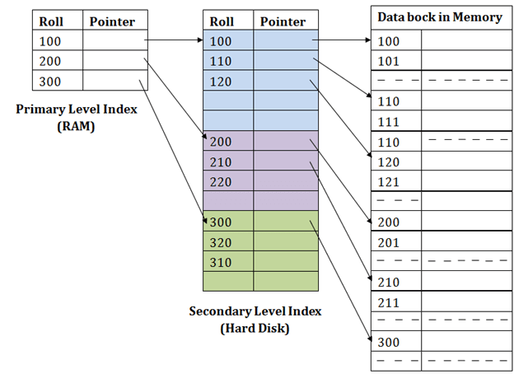
For example:
- If you want to find the record of roll 111 in the diagram, then it will search the highest entry which is smaller than or equal to 111 in the first level index. It will get 100 at this level.
- Then in the second index level, again it does max (111) <= 111 and gets 110. Now using the address 110, it goes to the data block and starts searching each record till it gets 111.
- This is how a search is performed in this method. Inserting, updating or deleting is also done in the same manner.

B+ Tree
- The B+ tree is a balanced binary search tree. It follows a multi-level index format.
- In the B+ tree, leaf nodes denote actual data pointers. B+ tree ensures that all leaf nodes remain at the same height.
- In the B+ tree, the leaf nodes are linked using a link list. Therefore, a B+ tree can support random access as well as sequential access.

Rules for B+ Tree
Here are essential rules for B+ Tree.
- Leaves are used to store data records.
- It stored in the internal nodes of the Tree.
- If a target key value is less than the internal node, then the point just to its left side is followed.
- If a target key value is greater than or equal to the internal node, then the point just to its right side is followed.
- The root has a minimum of two children.

Why use B+ Tree
Here, are reasons for using B+ Tree:
- Key are primarily utilized to aid the search by directing to the proper Leaf.
- B+ Tree uses a “fill factor” to manage the increase and decrease in a tree.
- In B+ trees, numerous keys can easily be placed on the page of memory because they do not have the data associated with the interior nodes. Therefore, it will quickly access tree data that is on the leaf node.
- A comprehensive full scan of all the elements is a tree that needs just one linear pass because all the leaf nodes of a B+ tree are linked with each other.

Structure of B+ Tree
- In the B+ tree, every leaf node is at equal distance from the root node. The B+ tree is of the order n where n is fixed for every B+ tree.
- It contains an internal node and leaf node.
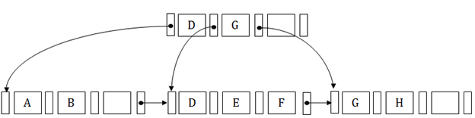

Internal node
- An internal node of the B+ tree can contain at least n/2 record pointers except the root node.
- At most, an internal node of the tree contains n pointers.

Leaf node
- The leaf node of the B+ tree can contain at least n/2 record pointers and n/2 key values.
- At most, a leaf node contains n record pointer and n key values.
- Every leaf node of the B+ tree contains one block pointer P to point to next leaf node.

Searching a record in B+ Tree
Suppose we have to search 55 in the below B+ tree structure. First, we will fetch for the intermediary node which will direct to the leaf node that can contain a record for 55.
So, in the intermediary node, we will find a branch between 50 and 75 nodes. Then at the end, we will be redirected to the third leaf node. Here DBMS will perform a sequential search to find 55.
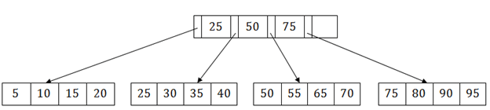

B+ Tree Insertion
Suppose we want to insert a record 60 in the below structure. It will go to the 3rd leaf node after 55. It is a balanced tree, and a leaf node of this tree is already full, so we cannot insert 60 there.
In this case, we have to split the leaf node, so that it can be inserted into tree without affecting the fill factor, balance and order.M
982
Features of Java - Javatpoint
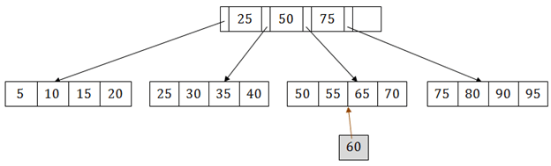
The 3rd leaf node has the values (50, 55, 60, 65, 70) and its current root node is 50. We will split the leaf node of the tree in the middle so that its balance is not altered. So we can group (50, 55) and (60, 65, 70) into 2 leaf nodes.
If these two has to be leaf nodes, the intermediate node cannot branch from 50. It should have 60 added to it, and then we can have pointers to a new leaf node.
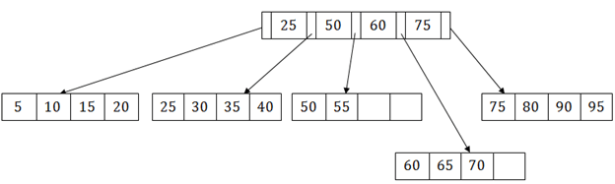
This is how we can insert an entry when there is overflow. In a normal scenario, it is very easy to find the node where it fits and then place it in that leaf node.

B+ Tree Deletion
Suppose we want to delete 60 from the above example. In this case, we have to remove 60 from the intermediate node as well as from the 4th leaf node too. If we remove it from the intermediate node, then the tree will not satisfy the rule of the B+ tree. So we need to modify it to have a balanced tree.
After deleting node 60 from above B+ tree and re-arranging the nodes, it will show as follows:
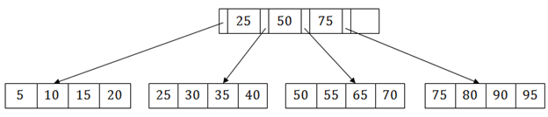

Example- 1: Construct B+ tree to insert the following (order of the tree is 3)
26,27,28,3,4,7,9,46,48,51,2,6
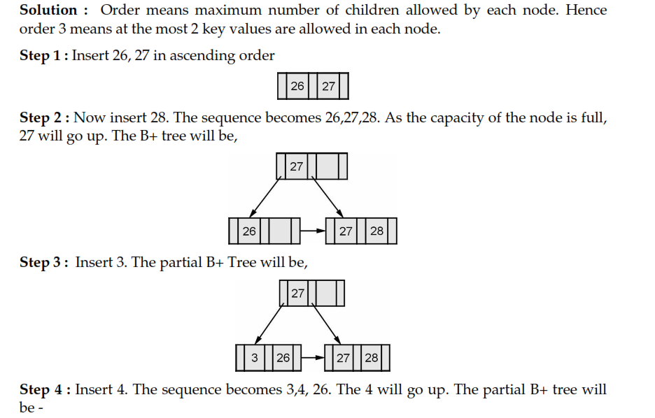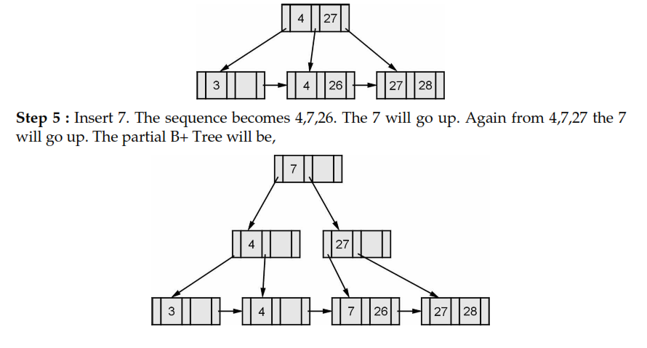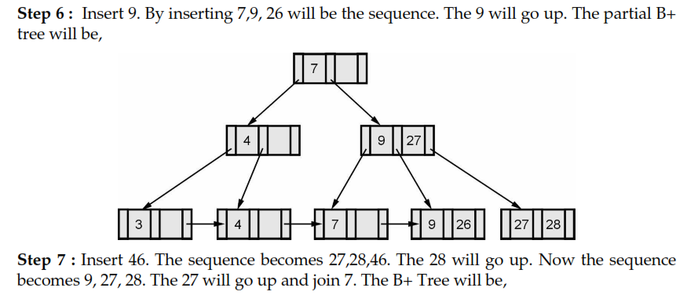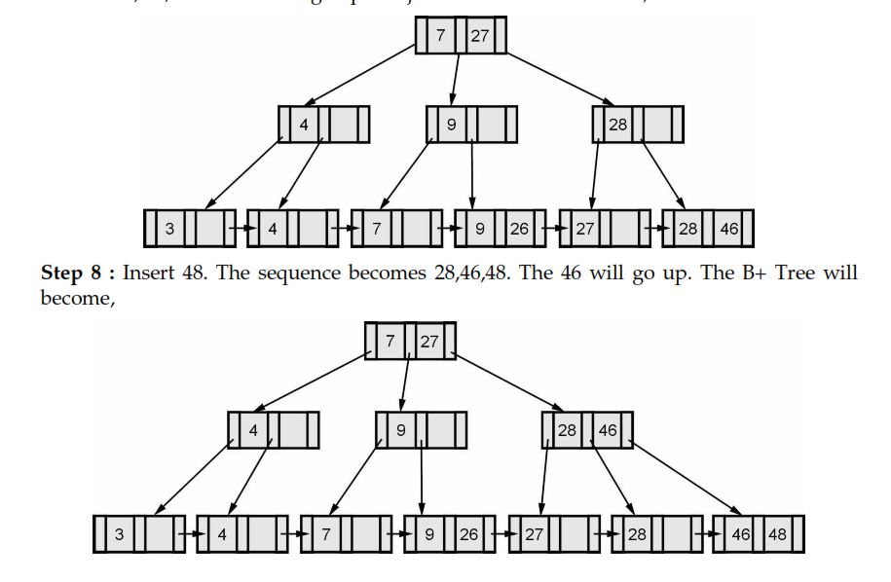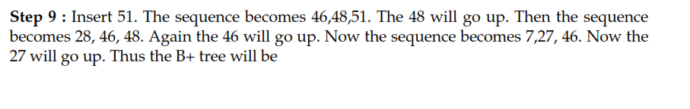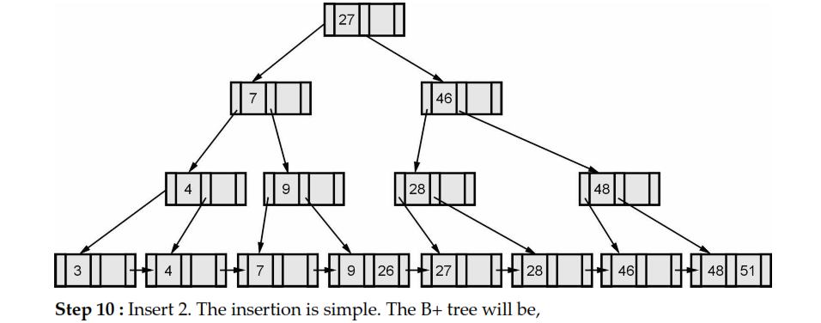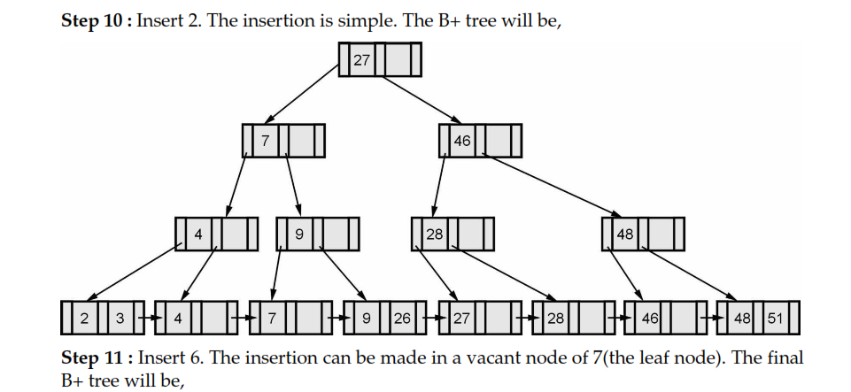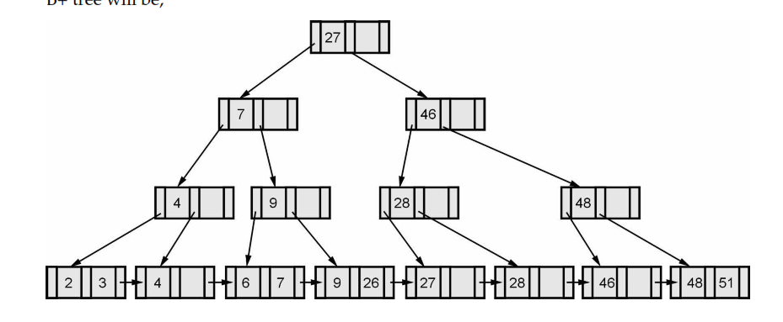

B Tree index Files

A B Tree Index is a multilevel index.
A B Tree is a rooted tree satisfying the following properties :
- All paths from the root to the leaf are equally long.
- A node that is not a root or leaf, has between [n / 2] and ‘n’ children.
- A leaf node has between [(n-1) / 2] and ‘n-1’ values.

The structures of leaf, non-leaf nodes of this tree is :
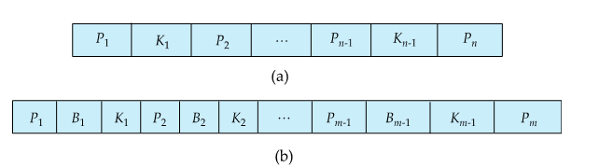

B tree index file is similar to B+ tree index files, but it uses binary search concepts. In this method, each root will branch to only two nodes and each intermediary node will also have the data. And leaf node will have lowest level of data. However, in this method also, records will be sorted. Since all intermediary nodes also have records, it reduces the traversing till leaf node for the data. A simple B tree can be represented as below:
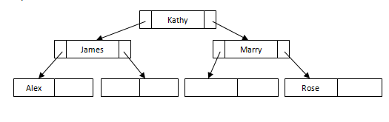
See the difference between this tree structure and B+ tree for the same example above. Here there is no repetition or pointers till leaf node. All the records are stored in all the nodes. If we need to insert any record, it will be done as B+ tree index files, but it will make sure that each node will branch only to two nodes. If there is not enough space in any of the node, it will split the node and store the records.
Example of Simple Insert
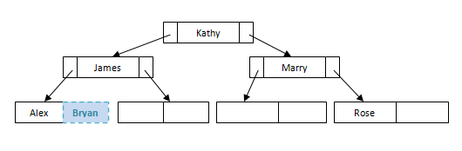

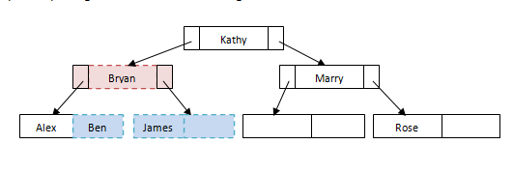
Advantages:
- Lack of redundant storage (but only marginally different).
- Some searches are faster (key may be in non-leaf node).
Disadvantages:
- Leaf and non-leaf nodes are of different size (complicates storage)
- Deletion may occur in a non-leaf node (more complicated)
Generally, the structural simplicity of B -tree is preferred.
Example-1: Construct a B- Tree for the following search key values, where n = 3.
{10, 20, 30, 40, 50}
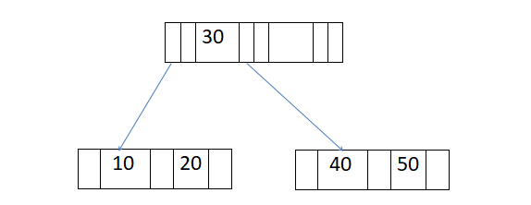
Let’s take another example and insert, delete elements from the tree
Example-2: Construct a B- Tree for the following search key values, where n = 3. (n is no of pointers)
{10, 20, 30, 40, 50, 60, 70, 80, 90}
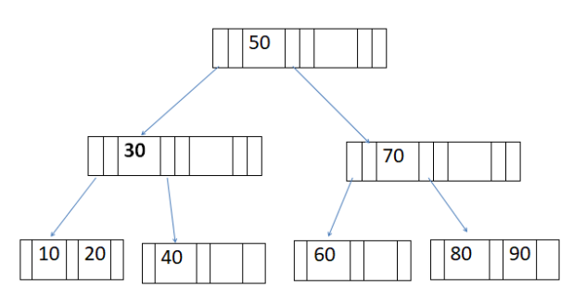
- a) Delete 20 from above tree.
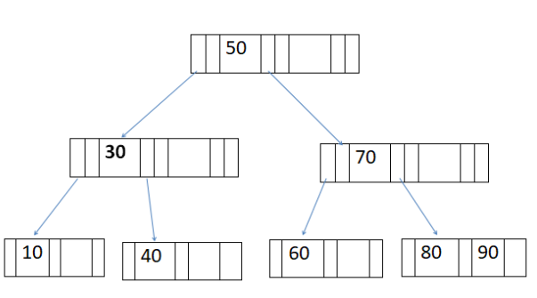
- b) Insert 65 to the above tree.
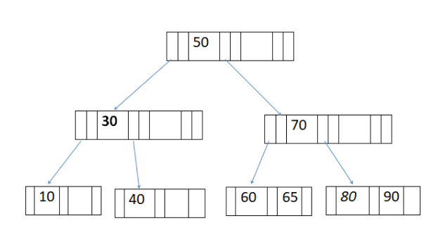

Static Hashing
In static hashing, the resultant data bucket address will always be the same. That means if we generate an address for EMP_ID =103 using the hash function mod (5) then it will always result in same bucket address 3. Here, there will be no change in the bucket address.
Hence in this static hashing, the number of data buckets in memory remains constant throughout. In this example, we will have five data buckets in the memory used to store the data.
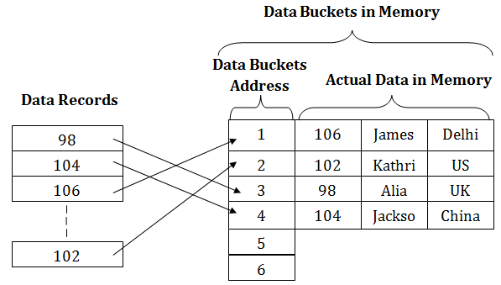

Operations of Static Hashing
- Searching a record
When a record needs to be searched, then the same hash function retrieves the address of the bucket where the data is stored.
- Insert a Record
When a new record is inserted into the table, then we will generate an address for a new record based on the hash key and record is stored in that location.Morial
- Delete a Record
To delete a record, we will first fetch the record which is supposed to be deleted. Then we will delete the records for that address in memory.
- Update a Record
To update a record, we will first search it using a hash function, and then the data record is updated.
If we want to insert some new record into the file but the address of a data bucket generated by the hash function is not empty, or data already exists in that address. This situation in the static hashing is known as bucket overflow. This is a critical situation in this method.
To overcome this situation, there are various methods. Some commonly used methods are as follows:

1. Open Hashing
When a hash function generates an address at which data is already stored, then the next bucket will be allocated to it. This mechanism is called as Linear Probing.
For example: suppose R3 is a new address which needs to be inserted, the hash function generates address as 112 for R3. But the generated address is already full. So the system searches next available data bucket, 113 and assigns R3 to it.
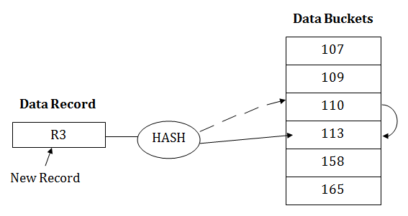

2. Close Hashing
When buckets are full, then a new data bucket is allocated for the same hash result and is linked after the previous one. This mechanism is known as Overflow chaining.
For example: Suppose R3 is a new address which needs to be inserted into the table, the hash function generates address as 110 for it. But this bucket is full to store the new data. In this case, a new bucket is inserted at the end of 110 buckets and is linked to it.
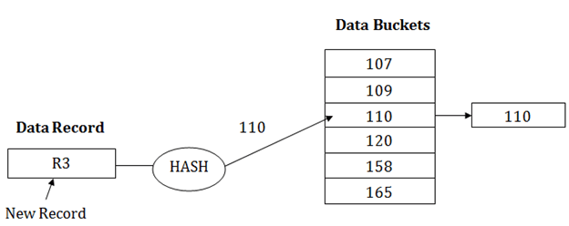
Hashing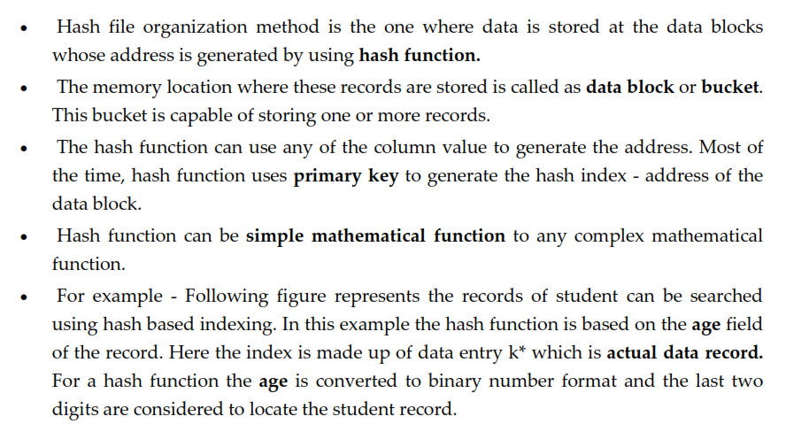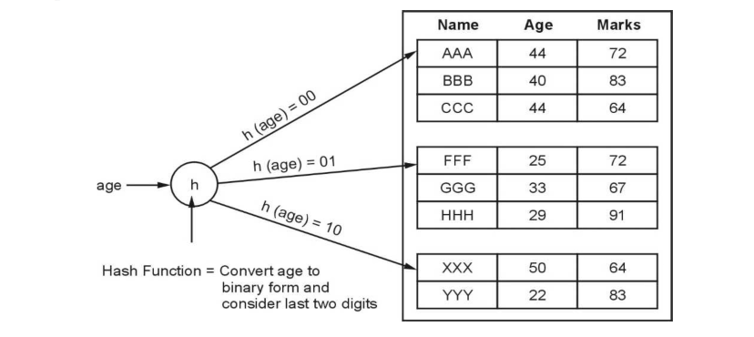Basic Terms used in Hashing
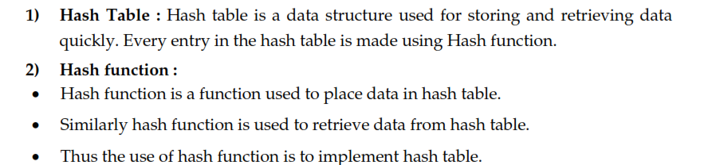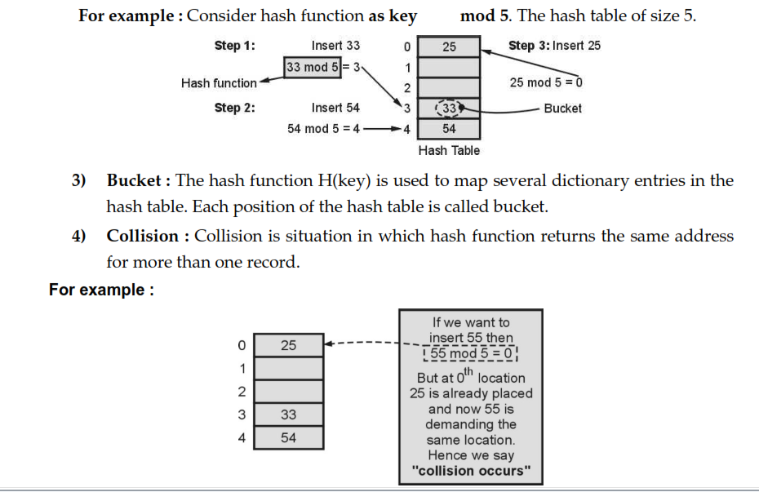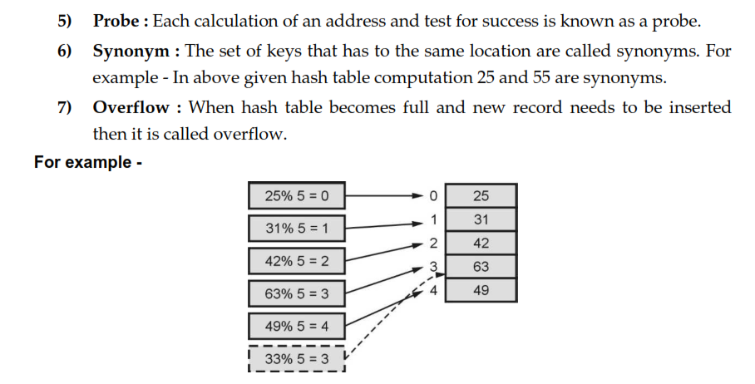

Dynamic Hashing
- The dynamic hashing method is used to overcome the problems of static hashing like bucket overflow.
- In this method, data buckets grow or shrink as the records increases or decreases. This method is also known as Extendable hashing method.
- This method makes hashing dynamic, i.e., it allows insertion or deletion without resulting in poor performance.

How to search a key
- First, calculate the hash address of the key.
- Check how many bits are used in the directory, and these bits are called as i.
- Take the least significant i bits of the hash address. This gives an index of the directory.
- Now using the index, go to the directory and find bucket address where the record might be.

How to insert a new record
- Firstly, you have to follow the same procedure for retrieval, ending up in some bucket.
- If there is still space in that bucket, then place the record in it.
- If the bucket is full, then we will split the bucket and redistribute the records.

For example:
Consider the following grouping of keys into buckets, depending on the prefix of their hash address:
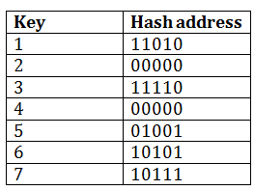
The last two bits of 2 and 4 are 00. So it will go into bucket B0. The last two bits of 5 and 6 are 01, so it will go into bucket B1. The last two bits of 1 and 3 are 10, so it will go into bucket B2. The last two bits of 7 are 11, so it will go into B3.
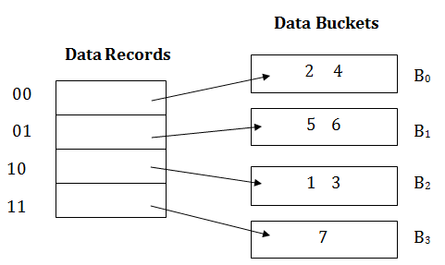

Insert key 9 with hash address 10001 into the above structure:
- Since key 9 has hash address 10001, it must go into the first bucket. But bucket B1 is full, so it will get split.
- The splitting will separate 5, 9 from 6 since last three bits of 5, 9 are 001, so it will go into bucket B1, and the last three bits of 6 are 101, so it will go into bucket B5.
- Keys 2 and 4 are still in B0. The record in B0 pointed by the 000 and 100 entry because last two bits of both the entry are 00.
- Keys 1 and 3 are still in B2. The record in B2 pointed by the 010 and 110 entry because last two bits of both the entry are 10.
- Key 7 are still in B3. The record in B3 pointed by the 111 and 011 entry because last two bits of both the entry are 11.
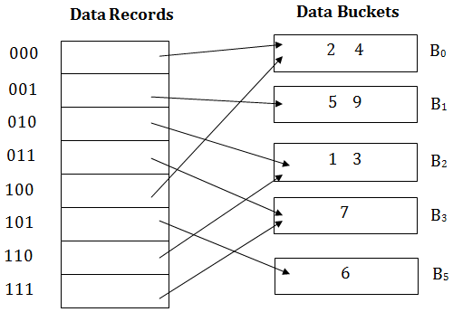

Advantages of dynamic hashing
- In this method, the performance does not decrease as the data grows in the system. It simply increases the size of memory to accommodate the data.
- In this method, memory is well utilized as it grows and shrinks with the data. There will not be any unused memory lying.
- This method is good for the dynamic database where data grows and shrinks frequently.

Disadvantages of dynamic hashing
- In this method, if the data size increases then the bucket size is also increased. These addresses of data will be maintained in the bucket address table. This is because the data address will keep changing as buckets grow and shrink. If there is a huge increase in data, maintaining the bucket address table becomes tedious.
- In this case, the bucket overflow situation will also occur. But it might take little time to reach this situation than static hashing.

Extendible Hashing
Extendible Hashing is a dynamic hashing method wherein directories, and buckets are used to hash data. It is an aggressively flexible method in which the hash function also experiences dynamic changes.
Main features of Extendible Hashing: The main features in this hashing technique are:

- Directories: The directories store addresses of the buckets in pointers. An id is assigned to each directory which may change each time when Directory Expansion takes place.
- Buckets: The buckets are used to hash the actual data.
Basic Structure of Extendible Hashing:
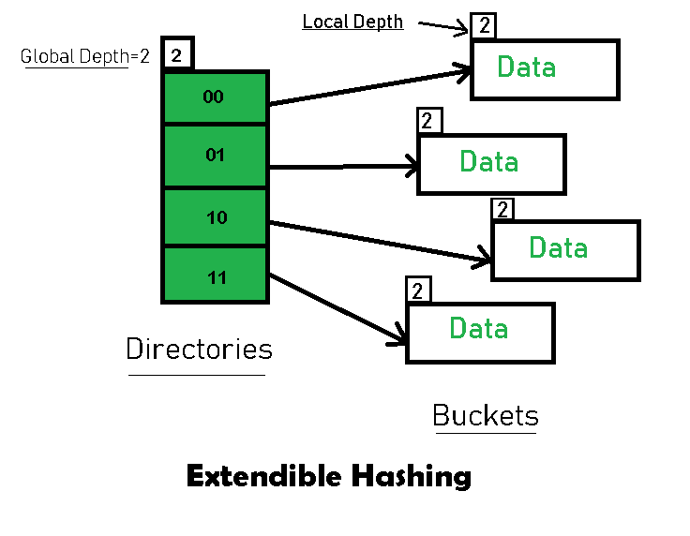
Frequently used terms in Extendible Hashing:
- Directories: These containers store pointers to buckets. Each directory is given a unique id which may change each time when expansion takes place. The hash function returns this directory id which is used to navigate to the appropriate bucket. Number of Directories = 2^Global Depth.
- Buckets: They store the hashed keys. Directories point to buckets. A bucket may contain more than one pointers to it if its local depth is less than the global depth.
- Global Depth: It is associated with the Directories. They denote the number of bits which are used by the hash function to categorize the keys. Global Depth = Number of bits in directory id.
- Local Depth: It is the same as that of Global Depth except for the fact that Local Depth is associated with the buckets and not the directories. Local depth in accordance with the global depth is used to decide the action that to be performed in case an overflow occurs. Local Depth is always less than or equal to the Global Depth.
- Bucket Splitting: When the number of elements in a bucket exceeds a particular size, then the bucket is split into two parts.
- Directory Expansion: Directory Expansion Takes place when a bucket overflows. Directory Expansion is performed when the local depth of the overflowing bucket is equal to the global depth.
Basic Working of Extendible Hashing:
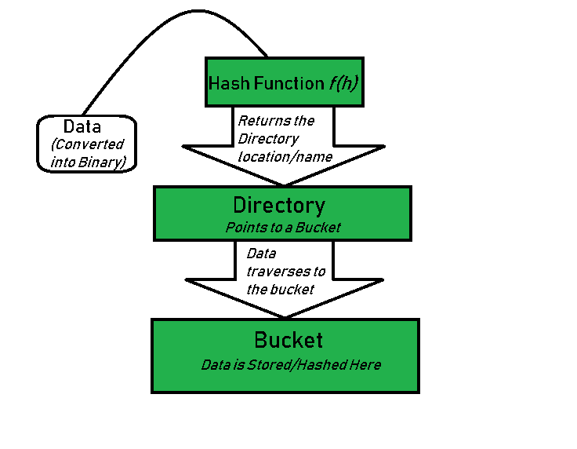

- Step 1 – Analyze Data Elements: Data elements may exist in various forms eg. Integer, String, Float, etc.. Currently, let us consider data elements of type integer. eg: 49.
- Step 2 – Convert into binary format: Convert the data element in Binary form. For string elements, consider the ASCII equivalent integer of the starting character and then convert the integer into binary form. Since we have 49 as our data element, its binary form is 110001.
- Step 3 – Check Global Depth of the directory. Suppose the global depth of the Hash-directory is 3.
- Step 4 – Identify the Directory: Consider the ‘Global-Depth’ number of LSBs in the binary number and match it to the directory id.
Eg. The binary obtained is: 110001 and the global-depth is 3. So, the hash function will return 3 LSBs of 110001 viz. 001.
- Step 5 – Navigation: Now, navigate to the bucket pointed by the directory with directory-id 001.
- Step 6 – Insertion and Overflow Check: Insert the element and check if the bucket overflows. If an overflow is encountered, go to step 7 followed by Step 8, otherwise, go to step 9.
- Step 7 – Tackling Over Flow Condition during Data Insertion: Many times, while inserting data in the buckets, it might happen that the Bucket overflows. In such cases, we need to follow an appropriate procedure to avoid mishandling of data.
First, Check if the local depth is less than or equal to the global depth. Then choose one of the cases below.
  - Case1: If the local depth of the overflowing Bucket is equal to the global depth, then Directory Expansion, as well as Bucket Split, needs to be performed. Then increment the global depth and the local depth value by 1. And, assign appropriate pointers.
Directory expansion will double the number of directories present in the hash structure.
  - Case2: In case the local depth is less than the global depth, then only Bucket Split takes place. Then increment only the local depth value by 1. And, assign appropriate pointers.
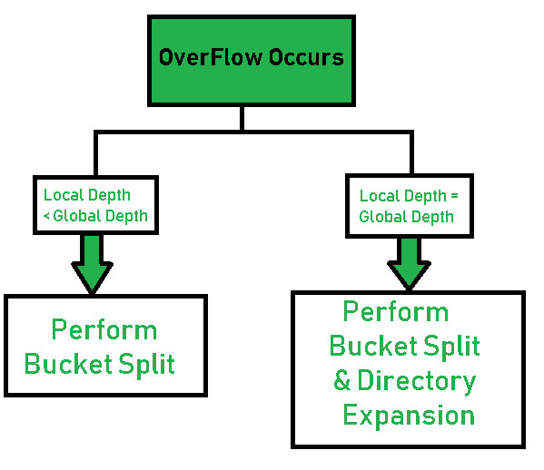
- Step 8 – Rehashing of Split Bucket Elements: The Elements present in the overflowing bucket that is split are rehashed w.r.t the new global depth of the directory.
- Step 9 – The element is successfully hashed.

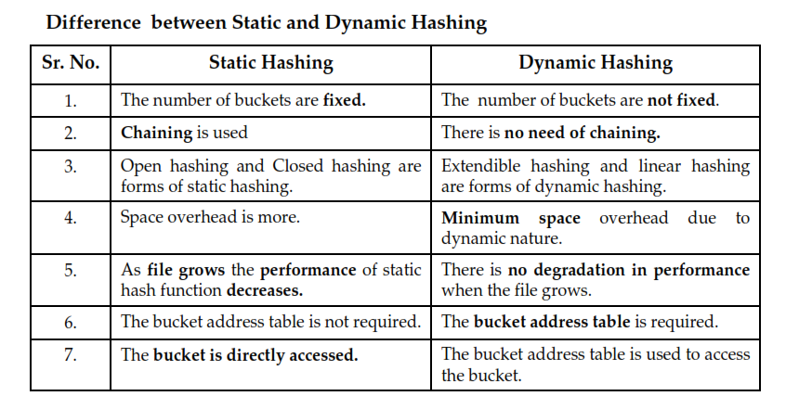

Query Processing in DBMS
Query Processing is the activity performed in extracting data from the database. In query processing, it takes various steps for fetching the data from the database. The steps involved are:
- Parsing and translation
- Optimization
- Evaluation
The query processing works in the following way:

Parsing and Translation
As query processing includes certain activities for data retrieval. Initially, the given user queries get translated in high-level database languages such as SQL. It gets translated into expressions that can be further used at the physical level of the file system. After this, the actual evaluation of the queries and a variety of query -optimizing transformations and takes place. Thus before processing a query, a computer system needs to translate the query into a human-readable and understandable language. Consequently, SQL or Structured Query Language is the best suitable choice for humans. But, it is not perfectly suitable for the internal representation of the query to the system. Relational algebra is well suited for the internal representation of a query. The translation process in query processing is similar to the parser of a query. When a user executes any query, for generating the internal form of the query, the parser in the system checks the syntax of the query, verifies the name of the relation in the database, the tuple, and finally the required attribute value. The parser creates a tree of the query, known as 'parse-tree.' Further, translate it into the form of relational algebra. With this, it evenly replaces all the use of the views when used in the query.
Thus, we can understand the working of a query processing in the below-described diagram:
36.4M
706
HTML Tutorial
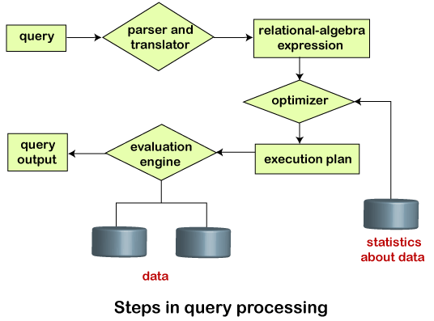
Suppose a user executes a query. As we have learned that there are various methods of extracting the data from the database. In SQL, a user wants to fetch the records of the employees whose salary is greater than or equal to 10000. For doing this, the following query is undertaken:
select emp_name from Employee where salary>10000;
Thus, to make the system understand the user query, it needs to be translated in the form of relational algebra. We can bring this query in the relational algebra form as:
- σ_{salary>10000} (π_{salary} (Employee))
- π_{salary} (σ_{salary>10000} (Employee))
After translating the given query, we can execute each relational algebra operation by using different algorithms. So, in this way, a query processing begins its working.

Evaluation
For this, with addition to the relational algebra translation, it is required to annotate the translated relational algebra expression with the instructions used for specifying and evaluating each operation. Thus, after translating the user query, the system executes a query evaluation plan.

Query Evaluation Plan
- In order to fully evaluate a query, the system needs to construct a query evaluation plan.
- The annotations in the evaluation plan may refer to the algorithms to be used for the particular index or the specific operations.
- Such relational algebra with annotations is referred to as Evaluation Primitives. The evaluation primitives carry the instructions needed for the evaluation of the operation.
- Thus, a query evaluation plan defines a sequence of primitive operations used for evaluating a query. The query evaluation plan is also referred to as the query execution plan.
- A query execution engine is responsible for generating the output of the given query. It takes the query execution plan, executes it, and finally makes the output for the user query.

Optimization
- The cost of the query evaluation can vary for different types of queries. Although the system is responsible for constructing the evaluation plan, the user does need not to write their query efficiently.
- Usually, a database system generates an efficient query evaluation plan, which minimizes its cost. This type of task performed by the database system and is known as Query Optimization.
- For optimizing a query, the query optimizer should have an estimated cost analysis of each operation. It is because the overall operation cost depends on the memory allocations to several operations, execution costs, and so on.
Finally, after selecting an evaluation plan, the system evaluates the query and produces the output of the query.

Algorithm for Select Operation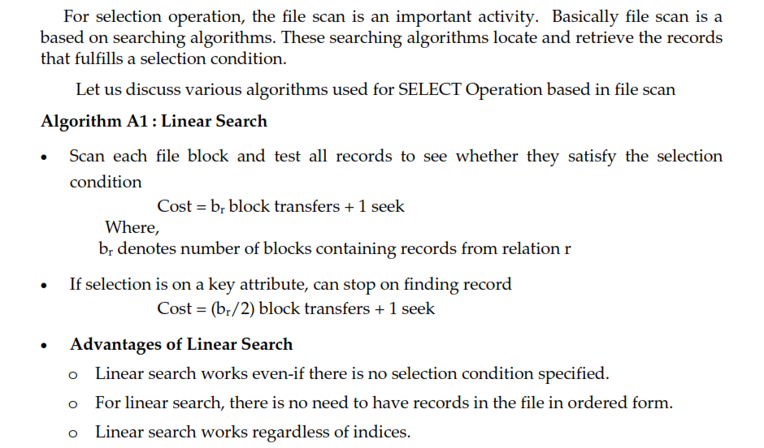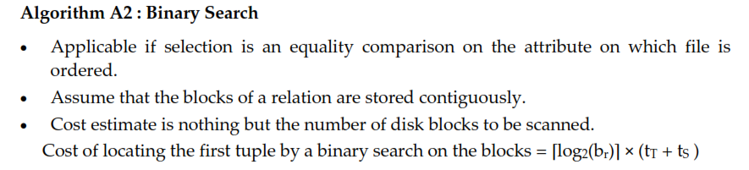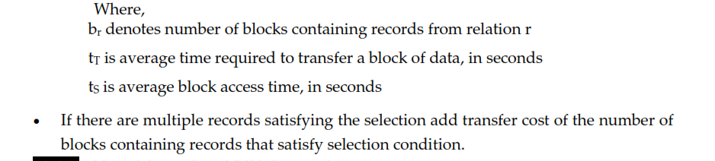

Algorithms for JOIN Operation 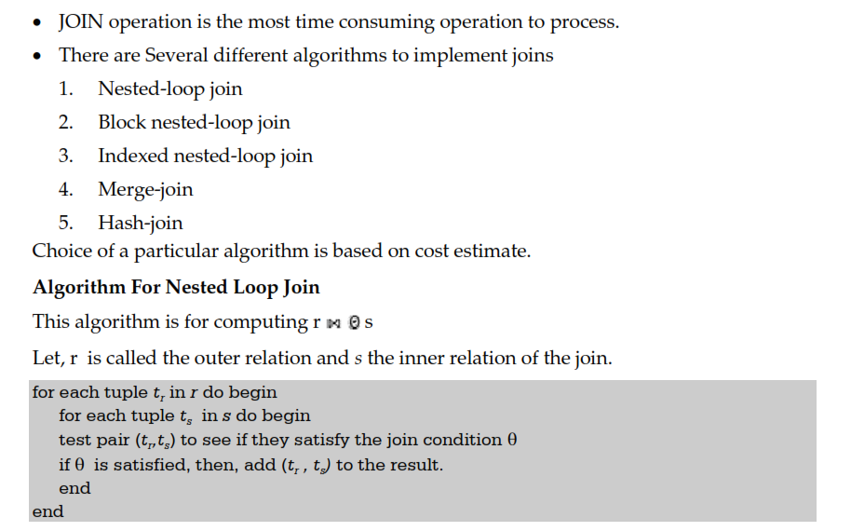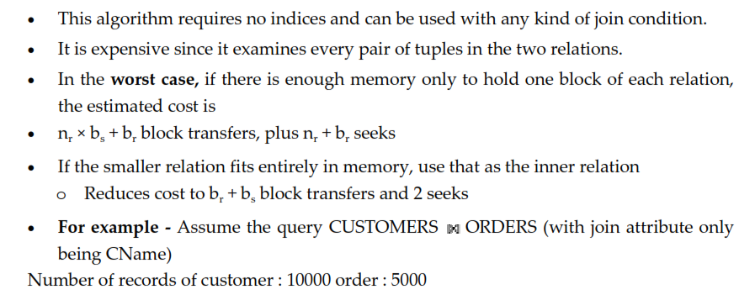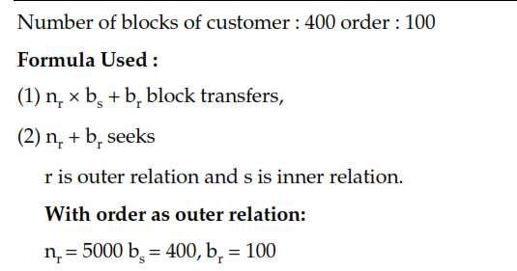
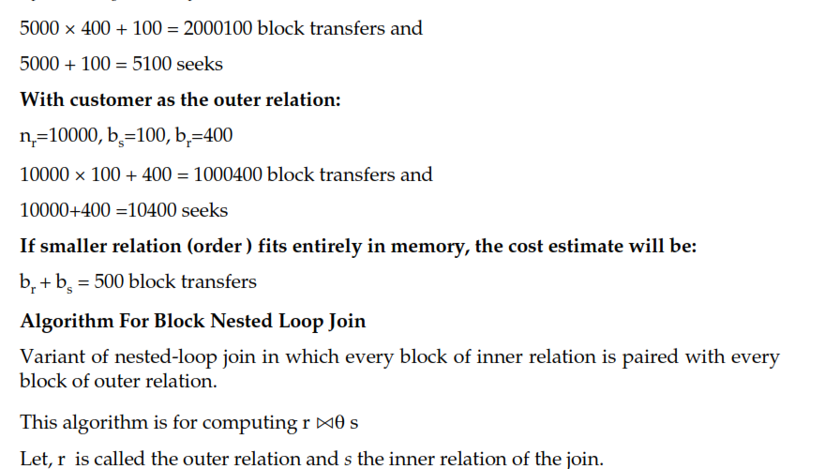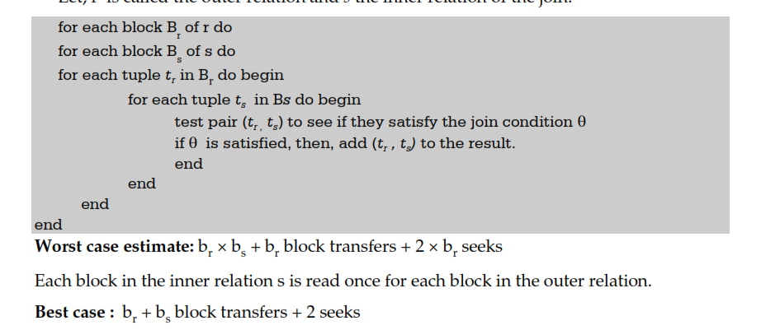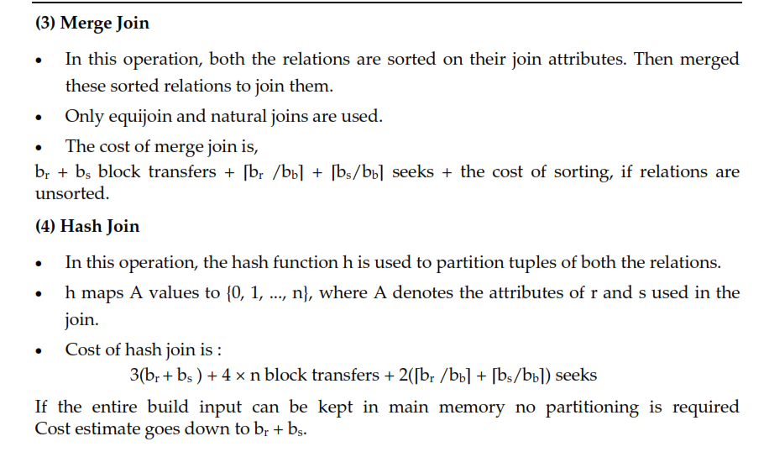
Query Optimization using Heuristics and Cost Estimation

Heuristic Estimation
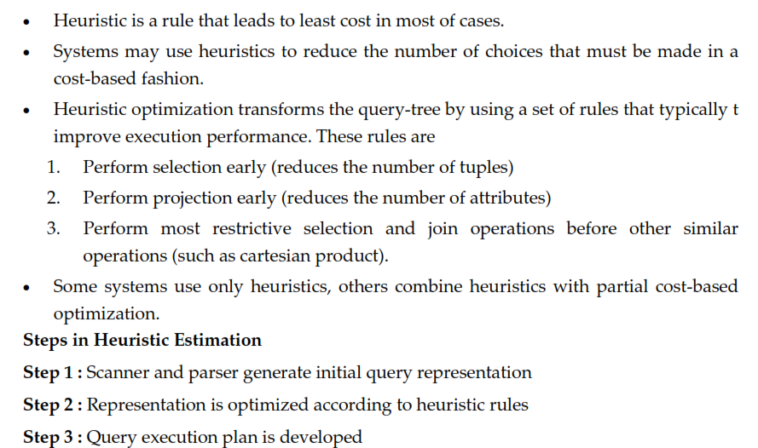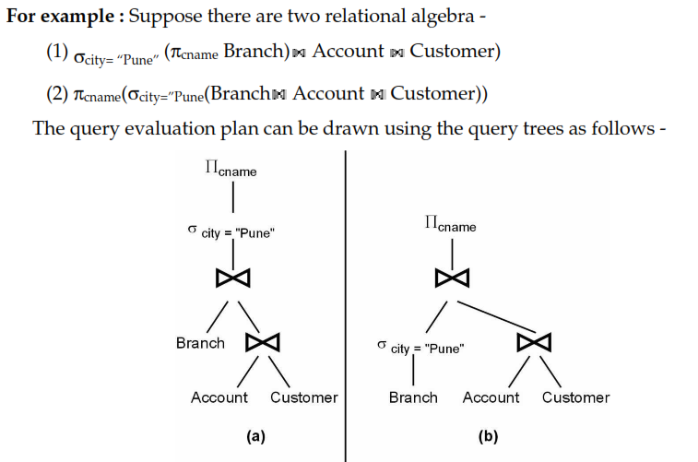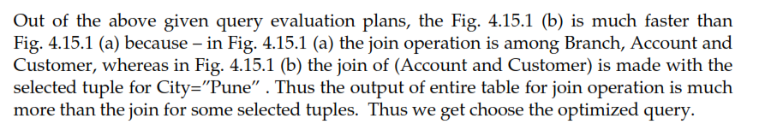

Cost based Estimation
